Read Cycle 68000 with 8MHz from EEPROM 28C64

$${3 X t}_{cyc}$$

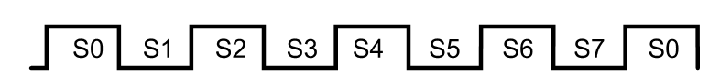

Valid Address

A

UDS/LDS

R/W

$$t_{DS}$$

$$t_{acc}$$

$$t_{AV}$$

D

Valid Data

$t_{acc}$: Memory access time, the time between address valid and data valid. $t_{DS}$: Data setup time.

$t_{AV}$: Address become valid (Clock Low to Address Valid)

3 $t_{cyc}$ = $t_{AV}+t_{ACC}+t_{DS}$

**Without** critical speed path (logic gates) the Memory Access time**:**

$3 X 125ns$ = $62ns+t_{ACC}+10ns$

$t_{ACC}$ = $303ns$

**With** critical speed path (logic gates) the Memory Access time:

Three logical gates cause delay; two NANDS and one NOR.

|  |  |  |  |  |  |
| --- | --- | --- | --- | --- | --- |
| NAND | $$t_{PLH}$$ | $$t_{PHL}$$ | NOR | $$t_{PLH}$$ | $$t_{PHL}$$ |
| MAX | 22 | 15 | MAX | 22 | 15 |
| MIN | 00 | 00 | MIN | 00 | 00 |

We are interested in the Pulse High to Low in both gates, and the maximum delay caused is 66ns

Therefore,

$3 X 125ns$ = $62ns+t_{ACC}+10ns+66ns$

$t_{ACC}$ = $237ns$ And the memories Maximum access time is 250ns therefore, it’s safe.